Caleb

Kitty

Szymon

Dorcas

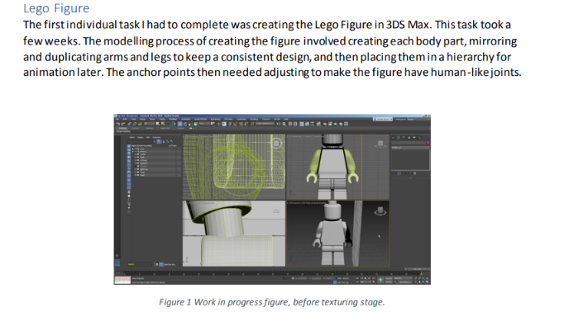

This is what it should look like, so write out the report for minifigures under our names. One minifigure per member and then in your personal report, you talk about how you did the other animations and coding and stuff.
So edit this file and push it the git hub when done.

